Erciyes Üniversitesi
Fen Bilimleri Enstitüsü Dergisi
Cilt 34, Sayı 2 , 2018

Erciyes University
Journal of Institue Of Science and Technology
Volume 34, Issue 2, 2018

From Immigrant Residences to Urban Transformation: Kayseri Eastern Turkestan Residences

Zübeyde Özlem PARLAK BİÇER¹, Barış ERGEN², Zeynep ERGEN^{1,} Meltem ULU^{1,} Merve KOÇAK GÜNGÖR²

¹ Erciyes Üniversitesi, Mimarlık Fakültesi, Mimarlık Bölümü, KAYSERİ
² Erciyes Üniversitesi, Mimarlık Fakültesi, Şehir ve Bölge Planlama Bölümü, KAYSERİ

(Alınış / Received: 18.05.2018, Kabul / Accepted: 30.08.2018, Online Yayınlanma / Published Online: 31.08.2018)
Keywords  Urban Transformation, Migration,  Immigrant Residences | Abstract: Migration, natural disasters and wear in structures that occur over time result in disruption and deterioration in structural areas. As a result, urban transformation works are started at structural areas by the users, local administrations and governments. Urban transformation works are carried out at a region instead of a structure where deterioration has occurred. Kayseri is one of the cities in Turkey where urban transformation has gained acceleration. In Kayseri, the Eastern Turkestan Residences, which is one of the immigrant housing samples of the city, is about to transform. This area is comprised of single or double storey residences with gardens. However, the fact that these residences have grown old due to use as well as the fact that they are located on an area in the city where unearned income possibilities have increased resulted in making this area an attractive spot for urban transformation. The sustainability of the physical texture of the city may be lost due to the urban transformation carried out at the Kayseri Turkestan Residences Quarter which is an example of the urban textures that have failed against the rapidly transforming city as well as the concept of unearned income. In this study, the current texture of the area in the city of Kayseri known as Eastern Turkestan Residences was examined and suggestions were made for the possible urban transformation. The objective of the study was to document the area prior to urban transformation and to pass the lost architectural values down to posterity. It is hoped that the study will contribute to future studies on the subject.
Göçmen Konutlarından Kentsel Dönüşüme: Kayseri Doğu Türkistan Konutları
Anahtar Kelimeler  Kentsel Dönüşüm,  Göç,  Göçmen Konutları | Öz: Göç, doğal afetler ve yapılarda zamanla meydana gelen yıpranmalar, yapı alanlarında bozulmaya yok olmaya sebep olmaktadır. Bunun sonucu olarak yapı alanlarında kullanıcılar, yerel yönetimler ve hükümetler tarafından kentsel dönüşüm çalışmaları başlatılmaktadır. Kentsel dönüşüm çalışmaları, yıpranma gerçekleşen bir yapı yerine bir bölge üzerinden gerçekleştirilmektedir. Türkiye’de kentsel dönüşüm uygulamalarının ivme kazandığı kentlerden Kayseri’de, yakın gelecekte, kentin göçmen konut örneklerinden Doğu Türkistan Konutlarının da dönüşmesi beklenmektedir. Bu alan, tek veya iki katlı bahçeli konutlardan oluşmaktadır. Fakat konutların kullanıma bağlı eskimesi ve gelişen kent içerisinde rant gelirlerinin arttığı bir noktada olması bu alanı kentsel dönüşüm için cazip bir yere dönüştürmüştür. Kentsel dönüşüm çalışmaları ile hızla dönüşen ve rant kavramına yenik düşen kent dokularına örnek olan Kayseri Türkistan Evleri Mahallesi’nde uygulanan kentsel dönüşüm ile kentin fiziksel dokusunun sürdürülebilirliği kaybedilmektedir. Bu çalışmada, Kayseri kenti içerisinde Doğu Türkistan Konutları olarak bilinen alandaki mevcut dokunun durumu incelenmiş ve yapılması muhtemel kentsel dönüşüm için öneriler sunulmuştur. Çalışma ile alanın kentsel dönüşüm öncesi belgelenmesi ve kaybolan mimari değerlerin gelecek kuşaklara aktarılması hedeflenmektedir. Çalışmanın, bundan sonra konu üzerinde yapılacak çalışmalara katkı sağlaması umulmaktadır.

1. Introduction

With the foundation of the republic, as a result of Ataturk’s desire to establish modern cities similar to European cities, and of the Treaty of Friendship with Germany signed on March 3, 1924, many foreign and especially German urban planners were invited to Turkey [1] [2]. The Garden City movement, which shows intellectual similarities with nature-oriented, biocentric movements and environmental protection movements (Heimatschutz) [1] [3] [4] [5], influenced German urban planners who made a contribution to the planned development of Turkey in that period. Many urban planning lecturers in Turkey have taught the influences of German Professor Bauhaus and Garden City movements. With the Garden City movement, Howard desired to establish self-sufficient housing zones that respect nature and the environment, and offer a high quality of life, vivid social life and easy access to workplaces [6] [7]. If sustainable development is briefly defined as the integration of environmental conservation, social equality and economic development in a comprehensive planning approach [8], it can be seen that the aims of sustainable development and the early twentieth century Garden City movement actually overlap.

According to Peter Newman and Jeffrey Kenworthy, the concept of sustainability is a result of a global political process and has gained increasing importance [9]. They defined sustainability as: economic development to overcome poverty, protecting the environment that we need, providing social justice and cultural diversity and displaying own values through local communities. Sustainable development makes no concessions about the needs of future generations while meeting today’s needs [10] [11]. In terms of architecture and urban planning, one of the needs of future generations is to protect the built environment and to hand it down intact. Urban development process not only involves urban wear and tear, but change can be necessary to comply with social and economic conditions [12] [13]. One of the most important approaches to ensuring change in cities is urban regeneration. According to Roberts et al., urban regeneration is the ensemble of integrated actions for the resolution of urban problems and the improvement of cities' economic, physical, social and environmental condition [14]. Urban regeneration is also important to urban sustainability. Maintaining the built environment means understanding the past at present and in the future. In terms of planning, construction, management and urban regeneration, today's most important needs are finance sector and economic development [15]. Economic changes in cities also change their physical structure. The built environment that was established with economic concerns is being defeated by urban rent, and we are losing architectural experiences, which should be passed on to future generations. Our urban textures are degraded and lost by being defeated by rent, sometimes historic environments and sometimes recent architectural works.

As a result of our planning system influenced by Garden City and Bauhaus, neighbourhoods and housing zones with gardens have been built in many cities, sometimes with the name of garden cities and sometimes with different names. In Kayseri province, Turkey, Turkestan Houses includes housing that were built by the government for migrants and built appropriately for this low-rise housing type with gardens. Failing to maintain this housing texture will lead to the loss of our recent architectural works and architectural experiences.

For this reason, it is important to ensure the sustainability of green areas with gardens and low-density housing while the urban transformation is being carried out. Previously implemented practices will also be helpful for new urban transformation studies. In this study, the present situation of Turkmen Houses in Kayseri Hoca Ahmet Yesevi Quarter was examined. Kayseri is a city where urban transformation is pace. In Kayseri, a field study was carried out on the selected area and suggestions were given for the urban transformation to be carried out in the following years. It is hoped that the work will contribute to the subject.

2. Material and Method

Hoca Ahmet Yesevi Neighborhood Turkmen residences located in the development area of Kayseri is one of the few residential areas with gardens located near the city center. It is also an example of a residential area where the population, the green area and the equilibrium, are produced as immigrant housing, and the cultural values and experiences of the settled immigrants are connected with the interventions and contributions they have made to the area. However, this residential area has recently fallen under the scope of urban transformation and has begun to lose its original structure. Field study was considered important in the study. On-site examinations and documentation were carried out in the aim of putting the original identity of the field which is formed by the influence of modern architecture and urbanism period, and they were tried to be interpreted through the maps. After the general characteristics of the settlement have been determined, researches have been carried out for the future urban transformation to be healthy. It is acknowledged that there are more green field losses in urban transformation implementations. For this reason, this study concentrates on what to do in order to avoid the disappearance of green areas after the transformation and to ensure its sustainability. Suggestions are presented by means of the obtained data. It is hoped that the work will also contribute to local governments.

3. Results

Kayseri has a central location within the country as a geographical location (Figure 1). Kayseri, which is an industrial and commercial city, has shown a planned development after the establishment of the Republic of Turkey. At the same time, the city also has garden city examples which are one of the sustainable planning approaches in the world. East Turkestan Houses discussed in this context are located in the north of Kayseri city, at a distance of 3.5 km from the city center, 2 km from the airport and covering 15.000 m² (Figure 2).

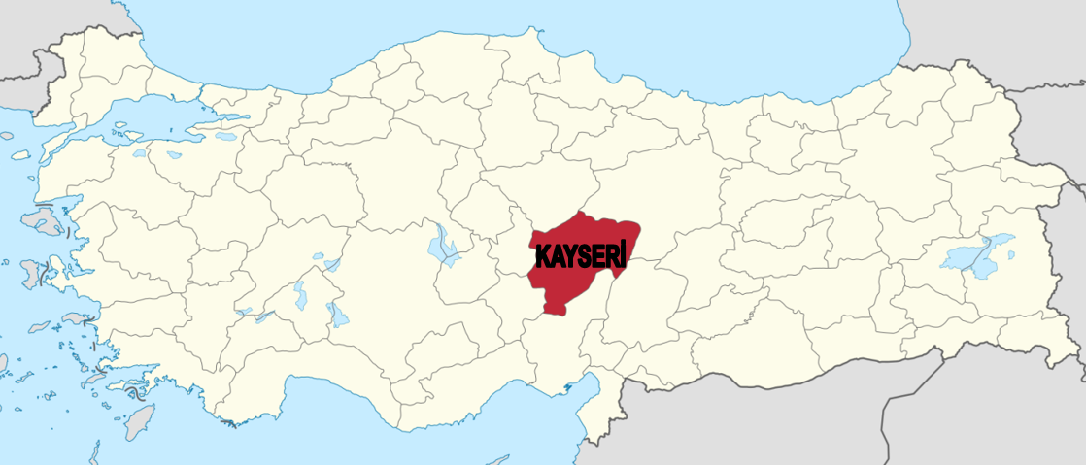
Figure 1. The location of Kayseri [16]

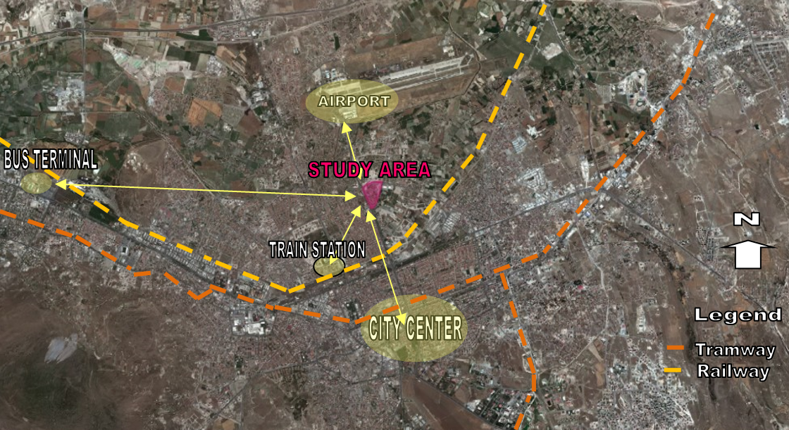
Figure 2. The Location and Connections of Kayseri Eastern Turkestan Residences [17]

The density of the green areas in the settlement is remarkable. The settlement consists of single and two storey houses, as well as attached houses (Figure 3).

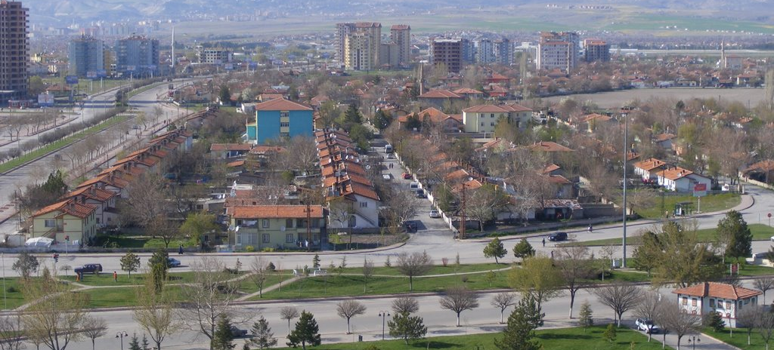

Figure 3. Aerial photo from south view [18]

The residential area was a settlement built in 1966 for people from Turkmenistan who had been laid-off and forced to migrate from their own country, but over time the users changed hands. New users have also moved from another city to Kayseri. During the first period, housing distribution was provided through the Housing Section of the Ministry of Housing and Settlement. These houses have been forbidden to be sold to another person for 10 years. Over time, this sanction has been lifted. Ownership of the whole of the houses built for the people coming from the state due to forced migration is now in private persons.

The houses were originally planned as single storeys, but some residences were built in two storeys together with the large number of immigrants (Figure 4) The houses are adjacent to each other with garden walls. The parcel of each house, the area, the location and the size of the building in the area have the same size. The total land use areas of residential buildings constructed as two storeys adjacent to each other are determined in the range of 900-1000 m². The main entrance of the houses is reached by the entrance of the garden with its wall which is made later by the local government. Houses built in 1966 have undergone change overtime with extensions of plans and façades according to the needs of the users. This situation caused a sense of irregular settlement and wreckage.

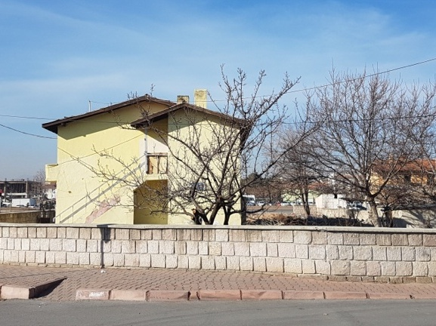 | 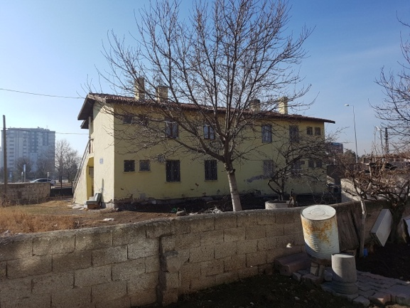
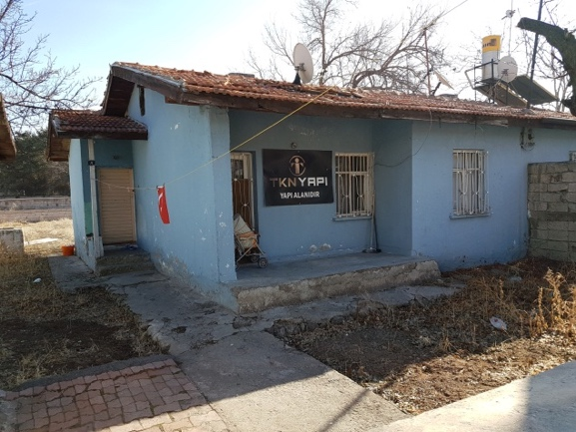 | 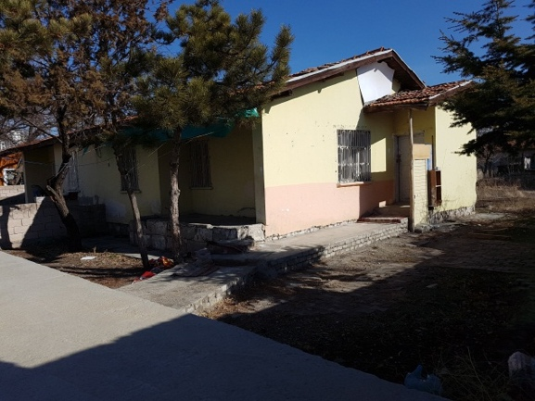

Figure 4. Examples of original houses

The single-storey residences are 65 m² in size. In the plan, the ratio of the wet area and the kitchen are small (Figure 5) Small balconies of the houses having a bedroom that is reached from the living space are closed down over time and joined the interior. The materials used during this process additionally gave an idle appearance to the houses (Figure 6). Some single storey houses were built as attached buildings and this creates a sense of a larger green area.

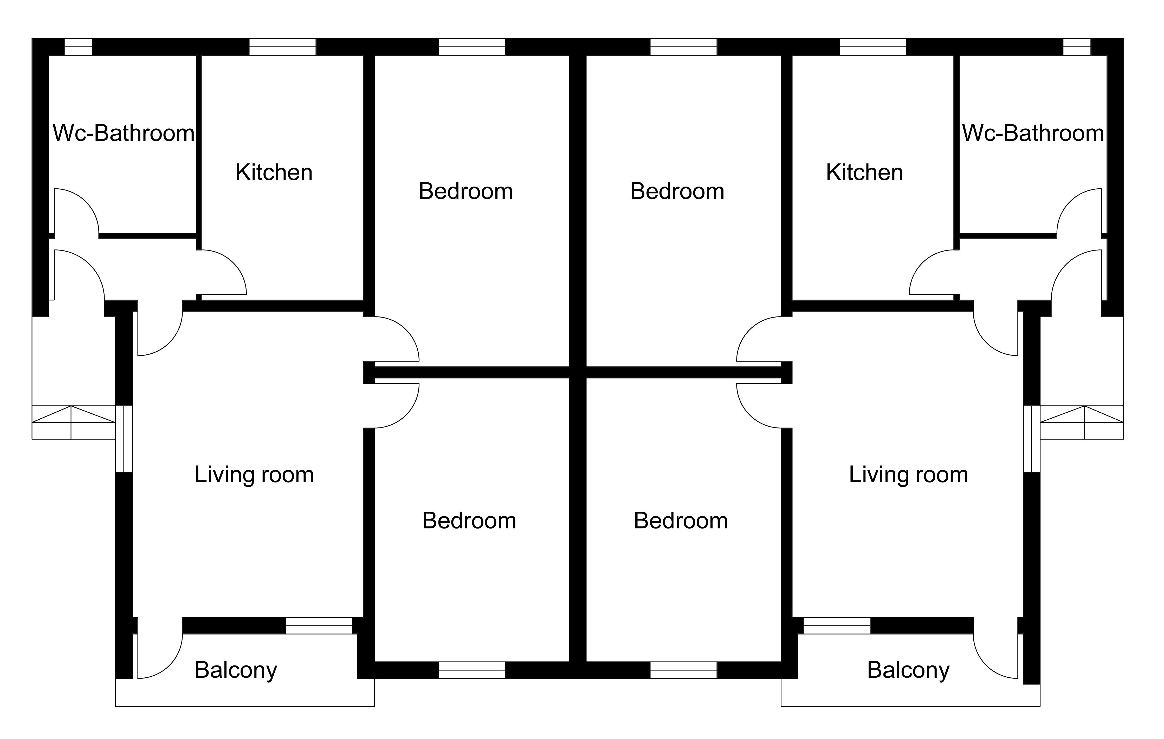

Figure 5. Plan scheme of single-storey residences

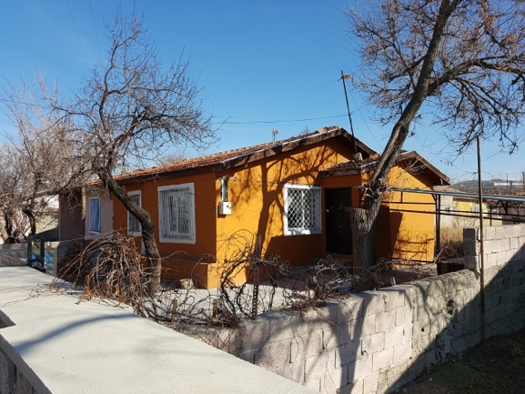 | 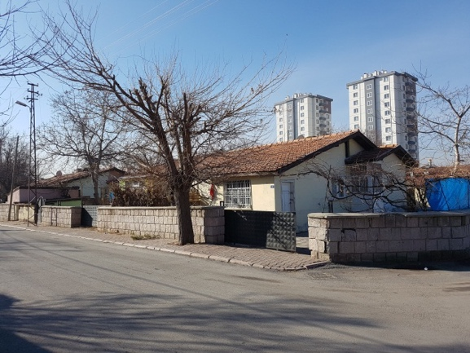
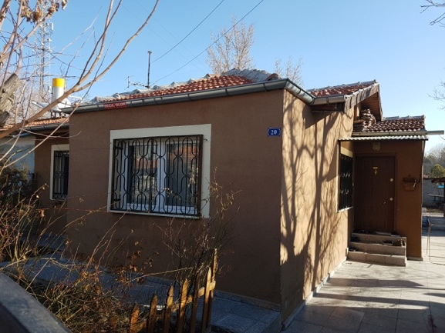 | 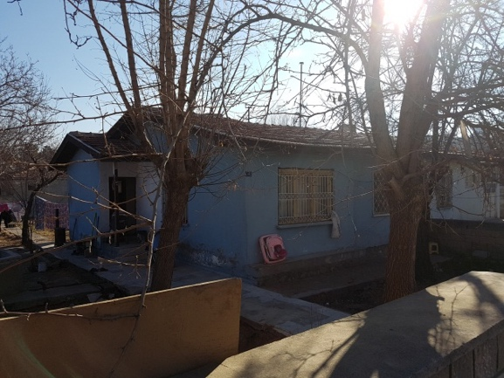

Figure 6. Extension and enclosure in single-storey houses

Two-storey residential buildings in the area are also located at 65 m². In two-storey houses constructed using the same plan scheme as single-storey houses, top-floor access is provided by an external ladder connection (Figure 7). Over time, it is observed that some of the staircases were constructed with an entrance space at the upper and lower levels, where some of these stairways were enclosed (Figure 8).
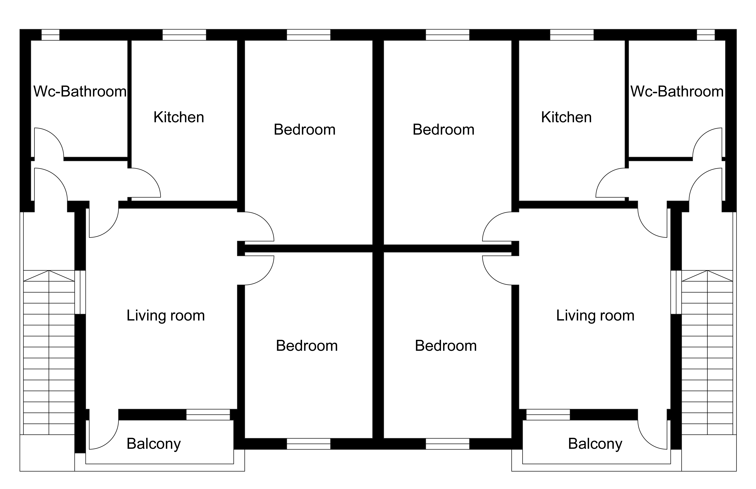

Figure 7. Plan scheme of two-storey residences

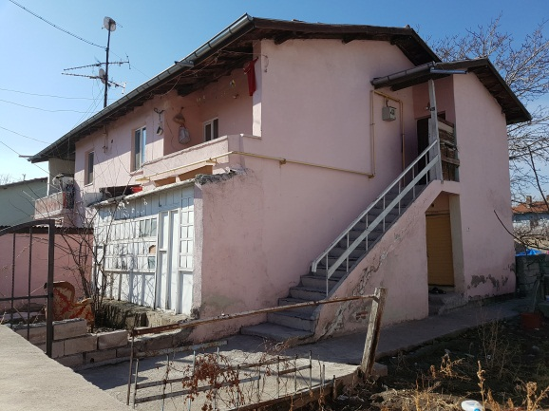 | 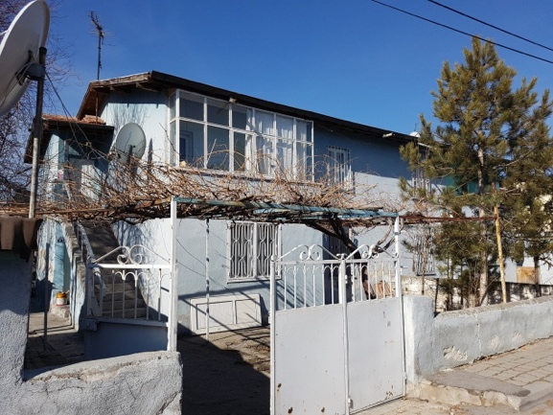
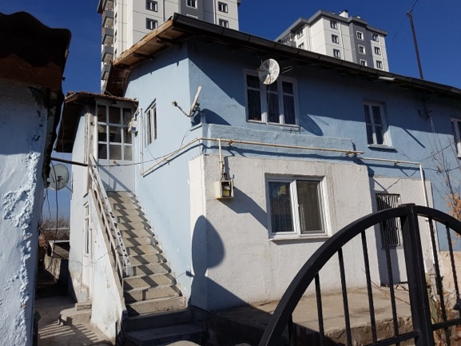 | 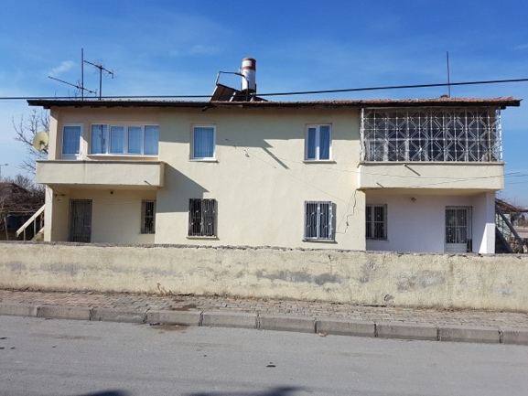

Figure 8. Extension and enclosure examples

The two-storey residential plan schemes and the changes made are similar to those of single-storey residences (Figure 9) In a few houses, extension and enclosure were more obvious. It is observed that the social areas are also involved in the planning in the settlement which consists of 84 attached and single storey, 116 attached and two storey houses and 200 single houses in total. Immigrant Mosque was built as a religious structure within the area. The necessary health unit is provided by the completion of the building used by the Housing Department and its conversion to a health center. An education building is also planned for the children of the families living here. The area designed for forced migrants is not just a place of welfare but also social facilities (Figure 10).

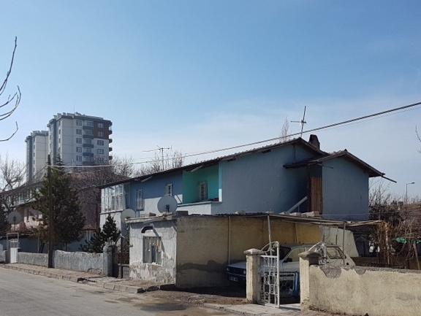 | 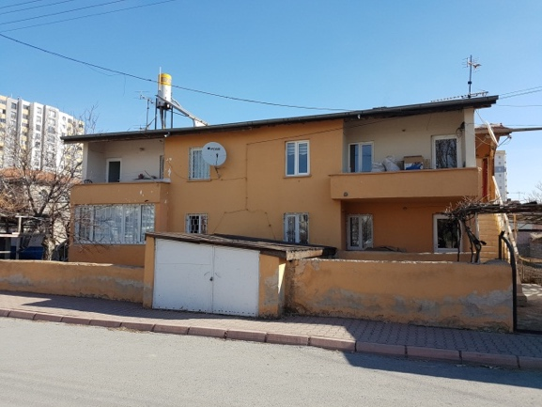
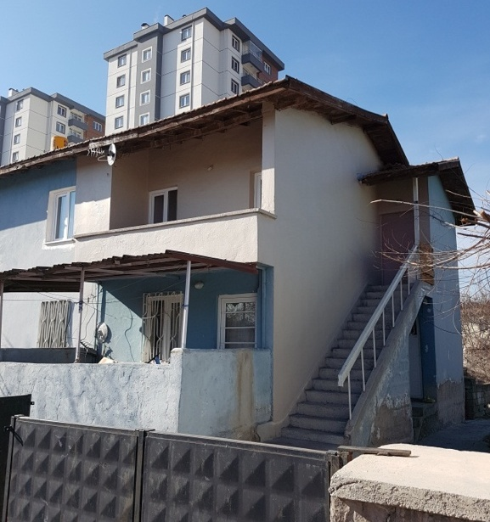 | 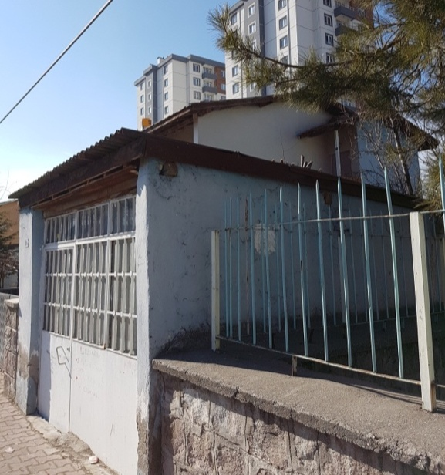

Figure 9. Extensions to the houses

The width of the green area in the residential area inside the garden does not come from only the residential gardens. At the same time, extensive park and garden areas are designed within the settlement for common use. It can be observed that the green area has not been compromised though the settlement is considered for forced migrants.

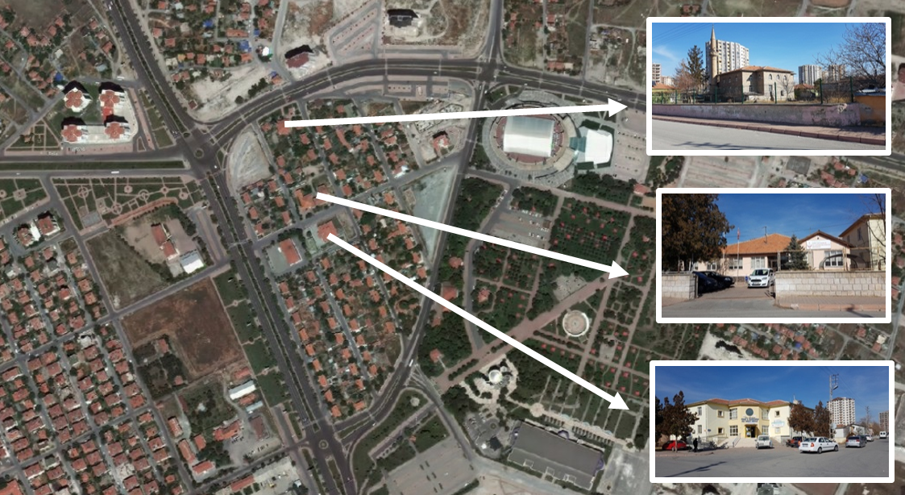

Figure 10. Social reinforcement areas (health center, school, mosque) [19]

Some data, such as the culture and the way of life that the users of the area manifest, have affected the use of open space in the residence and its surroundings. The change has been different in the residences with the users who bring along some unique features. This situation has also affected the perception of the area in question.
4. Discussion and Conclusion

In this study, the houses built by the Ministry of Housing and Urban Development for the families migrating from East Turkestan were examined within the context of urban transformation. In the study, the present conditions of the houses, plans and facade layouts were determined on site and social life was addressed in line with interviews with the families in the region. The region, which usually has a low-rise residential structure, is now releasing its place to multi-storey houses within the scope of urban transformation. This has damaged the social structure, which is in a single or twofold neighbour relation with social facilities.

In interviews with people living in the existing houses, it was emphasized that the houses were not stove-heated and insulated and that the size of the rooms was insufficient. It is stated that the houses constructed within the scope of urban transformation are centrally heated with elevator, and they are about twice as large as existing houses and that they provide more comfort for this reason. In the case of the previous settlement, the arrangement, which offers a garden life in low-rise houses, has begun to partly lead to a high-rise lifestyle lacking green area, which is preferred for better comfort conditions.

In terms of sustainability, Turkestan Houses have characteristics influenced by modern architecture and urbanism. Urban transformation will also cause the loss of this part of the city, which will adversely affect the sustainability of the built environment. Rapid urban transformation will lead to the rapid disappearance of urban memory. At this point, preservation of a certain part of the urban fabric that should be located in the memory of the city will be useful in terms of urban sustainability. In terms of sustainability, it is certain that the social relations regarding low-rise and the garden-city approach will deteriorate. On the other hand, the urban ecosystem formed around the low-rise residential houses will be negatively affected.

Besides, urban transformation is now being carried out through private companies, convincing housing owners individually or collectively. In practice, there are low-rise, low-density structure and high-rise, high-density structure. This is accomplished with a fragmented planning approach. When we look at the built environment that is transformed within the scope of urban transformation; it seems that it does not offer a healthy, qualified and balanced environment with sufficient green area, and that question of rent is held on the front line and is based on a non-integral planning approach. This situation is incompatible with the principle of sustainability.
It is observed that the area is at a location close to the city center and the development areas of the city. In this context, it is considered that the implementation of these transformations will be a negative example in terms of the future studies in the city and its immediate vicinity. For this reason, it is important to have a holistic planning with the understanding of sustainability. It is expected that this work contributes to the field and that local governments will be guided in future planning.

References

- Yiğit-Turan, B. 2016. Modernist landscapes of Ankara. Journal of Landscape Architecture, 11(2), 14-25.

- Cengizkan, A. (2004), Ankara’nın Ilk Planı 1924–25 Lörcher Planı: Kentsel Mekan Özellikleri, 1932 Jansen Planı’na ve Bugüne Katkıları, Etki ve Kalıntıları [The First Plan of Ankara 1924–1925: Lörcher’s Plan] Ankara: Ankara Enstitüsü Vakfı, Arkada Yayıncılık, 239s.

- Sohn, E. 2007. Organicist Concepts of City Landscape in German Planning after the Second World War. Landscape Research, 32(4), 499–523.

- Botar, O., and Wünsche, I. 2011. Biocentrism as a constituent element of Modernism. ss 1-14. Botar, O., and Wünsche, ed. 2011. Biocentrism and Modernism, Surrey and Burlington, Ashgate Publishing Limited, England, 288s.

- Haney, D. and Sohn E. 2011. Traces of Organicism in Gardening and Urban Planning Theories in Early Twentieth-Century Germany. ss. 107-126. Botar, O., and Wünsche, ed. 2011. Biocentrism and Modernism, Surrey and Burlington, Ashgate Publishing Limited, England, 288s.

- Lewis, J. 2015. Preserving and Maintaining The Concept of Letchworth Garden City. Planning Perspectives, 30(1), 153-163.

- Daniels, T.L. 2009. A Trail Across Time: American Environmental Planning from City Beautiful to Sustainability. Journal of the American Planning Association, 75(2), 178-192.

- Conroy, M.M., Jun, H.J. 2016. Planning Process Influences on Sustainability in Ohio Township Plans. Journal of Environmental Planning and Management 59(11), 2007-2023.

- Newman, P., Kenworthy, J. 1999. Sustainability and Cities: Overcoming Automobile Dependence. Washington D.C: Island Press, 442 p.

- Gibberd, J. 2015. Measuring Capability for Sustainability: The Built Environment Sustainability Tool (BEST). Building Research & Information, 43(1), 49-61.

- World Commission on Environment and Development (WCED). (1987). Our common future (The Brundtland Report). http://www.un-documents.net/our-common-future.pdf, accessed date: 05.06.2017

- Özden, P.P. 2008. Kentsel Yenileme, İmge Kitabevi Yayınları, 1. Baskı, İstanbul, 466s.

- Atalık, G. Çetiner, A. Göçer, O. Keskin, A. Özdeş, G., Suher, H. 1985. Şehircilik, İstanbul: İTÜ Matbaası, İstanbul, 336 s.

- Roberts P. 2017. The Evolution Definition and Purpose of Urban Regeneration, Roberts, 2 nd Edition. P. Sykes H., Granger, R. (eds.) in Urban Regeneration. SAGE Publications Ltd., London, 360p.

- Lützkendorf, T., Fan, W., Lorenz, D. 2011. Engaging Financial Stakeholders: Opportunities for a Sustainable Built Environment. Building Research & Information, 39(5), 483-503.

- Wikipedia, 2017. Turkey Map. https://tr.m.wikipedia.org/wiki/Dosya:Kayseri_in_Turkey.svg (Accessed Date: 05.07.2017).

- Citysurf Kayseri, 2017, “Kayseri area map”, version: 4_2_51, accessed date: 01.07.2017

- Panoramio, 2017, https://ssl.panoramio.com/photo/21838245, accessed date: 05.07.2017

- Google Earth 2017- Kayseri area map version… accessed date 01.07.2017

